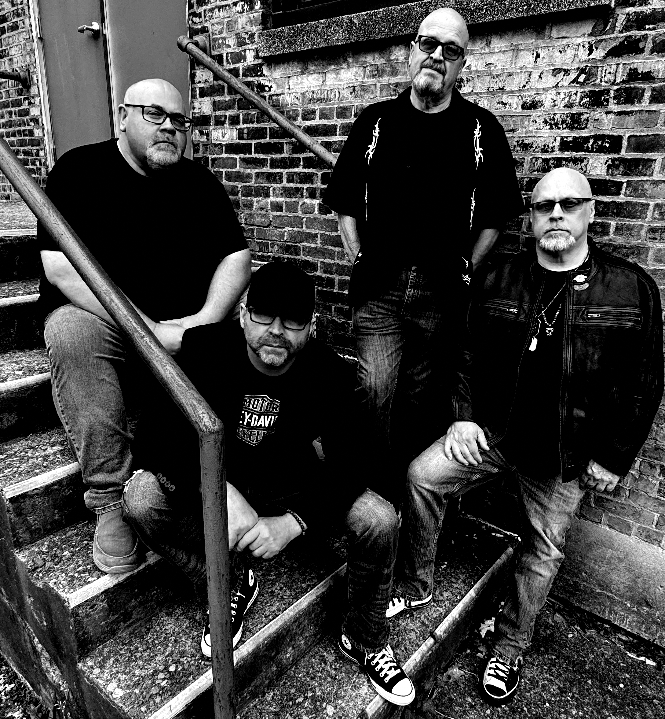

LIVE MUSIC!

**"Kick Ass Modern Rock and Killer Classic Rock like you've never heard before..."**